School of Computer Science and Engineering



PROJECT REPORT
BCSE309L Cryptography and Network Security
on
Elgamal Signature with Invalid Random k
Submitted by:
Sandeep Ganesh (23BRS1076)
Subal V R (23BRS1393)
Arumuga Selvan (23BRS1317)

Abstract:
The Elgamal Digital Signature Scheme is a classic digital encryption scheme in which the security and strength of the scheme rely on the hardness of Discrete Logarithmic Problem (DLP). Even though the theoretical foundation of the scheme is laid strong, it has a weakness. The correctness of the operation depends on the proper selection of random nonce and if any invalid or reused random nonce is used, the whole system gets compromised. The basic requirement gcd(k,q) = 1 where order q is a factor of p – 1. This ensures the equation becomes invertible and a signature pair can be calculated as it involves finding modular inverse of k (random nonce). If the condition is not met, the signing equation can fail and unclear signatures are produced.
The project examines how the choice of invalid random nonce affects the signature scheme, how the reused nonce can be used for creating forged signatures and finally how using the correct nonce (unique + GCD check) improves the security of the system and prevents any attack.
This study points the importance of strict arithmetic validation in cryptographic implementations and how it helps in the actual system behavior.
Introduction:
The ElGamal Signature Scheme is a digital signature algorithm that comes under public-key cryptography. It was developed to provide security services such as authentication, integrity and non-repudiation. The main concept behind this is Discrete Logarithmic problem where in y = g^{x}modp it is extremely difficult to find the private key x. This y provides high security.
In this signature scheme, there are two types of keys used: public key and private key. The private key is kept secure and is used to generate signatures. The public key is open to all and is used to verify the signature. This separation makes the system reliable and the actual owner of the private key can only generate signature. This provides high authenticity.
Important factor to node is the random nonce which is k. This must be generated fresh for every signature. This k must be random, unpredictable and never be reused under any circumstances. Even though this might look small, it plays a critical role and the entire security of the system could be compromised if not handled properly.
During the signing process, two values are generated as part of the signature (r,s). In order to compute one part of the signature which is s we would require modular inverse of k. This can only be computed only if GCD(k,q) = 1. This GCD=1 ensures that the equation is invertible and hence can compute k⁻¹. If GCD != 1, the system will fail to compute clear signatures.
In theory this may be overlooked but in real life implementation, choosing random nonce can potentially cause security threats and might lead to a catastrophic failure.
In this project, we study what happens when the nonce does not satisfy the required condition gcd(k,q) = 1. We look at both cases: one where this condition is ignored, and another where it is properly checked before signing. By comparing these approaches, we will show how such a validation step can make a big difference in ensuring secure operation of the ElGamal signature scheme.
Problem Statement
ElGamal Signature with Invalid Random k
The modular inverse of k mod q where order q is a factor of p-1 exists if and only if gcd(k, q) = 1. If an invalid k is chosen, that is, if gcd(k, q) != 1, then two outcomes are possible. The signing process may fail because the inverse does not exist. Or worse, it may produce signatures that behave unpredictably and open the door to forgery. In either case, the system stops being reliable. A digital signature scheme that occasionally fails to sign is already problematic. A scheme that produces weak or forgeable signatures is far worse. The issue is subtle because it does not arise from breaking the Discrete Logarithm Problem. It arises from violating a basic arithmetic condition that implementations sometimes assume will "just work."
Project Objectives Review
Python: To implement ElGamal signature generation and verification algorithms from scratch using python, with a Tkinter based graphical interface.
To intentionally allow invalid values to see and demonstrate signing failures and increased forgery behavior.
To introduce a preventative mechanism by requiring that one has gcd(k, p-1) = 1 and make a check before signing.
And in order to confirm that validations are properly done so as to avoid failure and forgery cases.
To generate structured invalid nonce values using q such that q divides (p-1), and analyze their impact on signature correctness
To measure performance metrics such as:
- Success and failure rates for signatures
- Forgery rates with invalid nonce conditions
- Latency overhead added by the gcd validation
- Execution time versus key size
Literature Survey
The ElGamal Signature Scheme is one of the basic public key signature schemes in cryptography, as introduced by Taher ElGamal in 1985. While ElGamal encryption is designed to safeguard the secrecy of a message (confidentiality), the ElGamal signature scheme relies on the algebraic properties of finite cyclic groups (the most frequently used of which is the multiplicative group modulo a prime , ) to ensure that the message indeed originates from the claimed sender (authentication and non-repudiation) and that it has not been tampered with (integrity).
The scheme works as follows: choose a large prime , a generator of the multiplicative group Zp. The next step is to make the public and private key pairs be (p,g,h), where h=gx and the private key is the exponent x. To sign a message m, the signer computes a pair (r, s) based upon a random ephemeral value and discrete logarithms inherent to the group. Verification then involves checking a congruence which ties together m, r, s, g and the public key.
The basic security of the ElGamal scheme is directly based on the Discrete Logarithm Problem (DLP). Given g and gx mod p, it is infeasible to compute x for sufficiently large primes with present algorithms and current computational limits. Forging a valid signature without a knowledge of the secret exponent x is computationally equivalent to solving the computationally hard DLP.in the underlying group. This reliance on the hardness of DLP makes ElGamal as important as the other foundational cryptographic assumptions such as integer factorization (used by RSA) and elliptic curve discrete logarithm problems. Standard textbooks of cryptography (e.g., Menezes, van Oorschot & Vanstone, 1996; Katz & Lindell, 2014) contain ElGamal as a classic example of a digital signature scheme for which the security is related to the infeasibility of solving the discrete logarithm problem. In simple terms, without the private key it would be impossible to forge a valid signature by solving a problem that is thought to be computationally infeasible.
The Vulnerability
Correct operation of ElGamal scheme requires careful choice of ephemeral random nonce for all signatures. In the signature calculation, k should be selected uniformly at random from the integers modulo p-1, and have a multiplicative inverse modulo p-1. In formal language, this means that gcd(k, p-1) = 1. If this condition fails, that is, if k has some factor, then the modular inverse k-1mod (p-1) does not exist. Since the second component of the signature s is calculated using this inverse, then this lack of ability to calculate k-1 leaves the signature equation unsolvable, which in effect breaks the algorithm at the signing stage.
Texts such as Stallings (2017) also this invertibility requirement, and makes reference to the requirement that the signer k be coprime to p-1 in order for undefined arithmetic to be avoided and also Paar & Pelzl (2010). Research papers analyzing algorithmic failure points (e.g. Schneier, 1996) explain the consequences of invalid k. Not only does the signing algorithm fail silently, the subtle implementations may generate malformed signatures that may be interpreted wrong or mishandled during the verification process, according to the research paper. Therefore, much of the cryptographic community pays as much attention to the generation and validation of k as it does to the generation of x itself, using rejection sampling or primality-aware random number generators to make sure that every chosen k has the property that gcd(k, p-1) =1.
Attack/Forgery Context
Apart from basic arithmetic failure, research on digital signature attacks indicates that inappropriate nonce selection can have much more serious consequences. If the nonce is reused, predictable or partially known, an attacker may be able to recover the private key, or be able to forge signatures. Although ElGamal was proposed before the problem of nonce misuse was analyzed in any depth, later schemes based on similar principles -- in particular the Digital Signature Algorithm (DSA), standardized by NIST in 1994 -- have been analyzed extensively. Since DSA closely resembles the mathematical structure of ElGamal, the takeaways gained from DSA are applicable directly here. Researchers have shown that if a nonce is repeated or if it has a predictable pattern, the signatures will constitute a linear relationship which can be used to recover the private key using only a small number of observed signatures. Studies on such linear relations by Koblitz & Menezes (2015) and Nguyen & Shparlinski (2001) rigorously explain how such linear relations arise, and how they can be solved efficiently. Furthermore, practical incidents have shown that even slightly biased random number generators -- e.g., with partial output leakage or predictable internal states - may allow real-world key recovery attacks, as documented by Heninger et al. (2012).
While these specific attacks target DSA, the principle holds for ElGamal: Both of these schemes rely on the unpredictability of and the freshness of . Indeed, many surveys of nonce vulnerabilities group together the failure modes of ElGamal-like schemes, emphasizing that invalid, reused, or predictable nonces undermine the presumed difficulty of the signature scheme and, in the worst case, render the security trivial. The consensus throughout this literature is clear - proper nonce management is as important to security as proper key generation, and errors in either can have catastrophic consequences to security in the areas of unforgeability and key confidentiality.
Proposed Gap
While we all learn from textbooks and research papers about the important role of nonce randomness and the need for gcd(k, p-1) =1, there still seems to be a gap in the understanding of how implementations actually detect and validate invalid values and how they react to them before it leads to runtime failures or potential subtle security breaches. The books explain the existence of a suitable and do not describe mechanisms for validating its properties nor analyze the performance implications of such validation in real-world systems. Furthermore, while most the books discuss the theoretical consequences of bad nonces it lacks empirical analysis as to how common invalid nonces occur under different random number generation strategies, or how interactive interfaces (such as GUI tools) may help developers and auditors visualize and prevent such failures.
This project fills that gap by implementing a graphical user interface (GUI) that not only performs ElGamal signature generation and verification, but also actively validates nonce choices, alerts users when violates gcd(k, p-1) =1, and logs performance metrics related to validation time and error rates. By combining easy-to-use visualization with formal arithmetic checks as well as performance profiling, the proposed work provides a tangible dimension to the theoretical need, so that the users of ElGamal become more aware of and can protect themselves from one of the less often mentioned vulnerabilities in ElGamal-like signature schemes.
Mathematical Background & Justification
A. Mathematical Model
Let VARIABLES
- p: A large prime number.
- g: A generator of the cyclic group Z*_{p}.
- x: Private key (1 < x < p-1)
- y: Public key defined as y = g^{x} (mod p)
- k: Random nonce selected for each signature.
- H(M): Hash of the message M.
ASSUMPTIONS:
DLP HARDNESS:
It is assumed that given gªmodp, a cannot be found in polynomial time
COLLISION RESISTANCE:
The hash function must be collision resistant such that no two messages have the same hash
EQUATIONS:
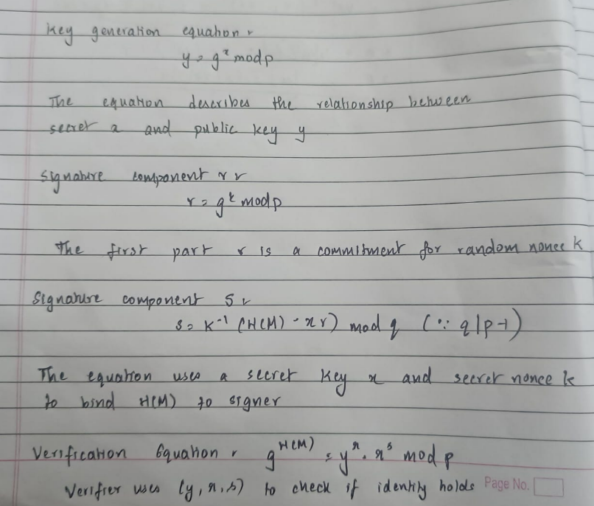
B. Mathematical Analysis
The signature generation converts primary key x and message hash H into verifiable signature pair (r,s)
Signature Generation
- Choose random k such that 1 < k < p-1
- Compute r = g^{k} (mod p)
- Compute s =k⁻¹ (H(M) – xr) (mod q) (such that q is a subgroup of p-1)
The inverse k⁻¹ exists if and only if gcd (k, q) =1.
Without invertibility, solving for s is no longer guaranteed.
Proof 1: Failure when gcd (k, q) != 1
Consider linear congruence: ks ≅ H(M) – xr (mod q)

Let d = gcd (k, q)
From number theory, as ≅ b(mod n) has a solution if and only if gcd (a,n) | b.

Here:
a=k
n=p-1
b=H(M) – xr
q q | (p-1)
Thus, a solution exists only if d| H(M) – xr. Hence two case arises:
Case 1: 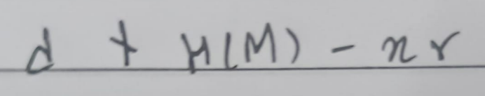- No solution exists. The signer cannot compute s. Authentication fails completely. (Denial of Service Condition)
Case 2: 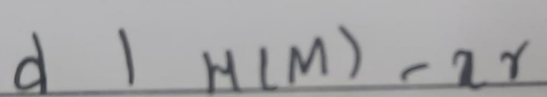 - There are exactly d distinct solutions
This leads to multiple possible $s$ values. The signature becomes not unique and weak.
Therefore, if gcd(k, q) != 1, the signing equation either:
- Has no solution, or
- Has multiple solutions.
This proves that invertibility of $k$ is necessary for correct and secure operation.
Proof 2: Correctness When gcd(k, p-1) = 1,
Given:
gcd(k, p-1) = 1
Hence k⁻¹ (mod p -1) exists.
Multiplying both sides by $k$:
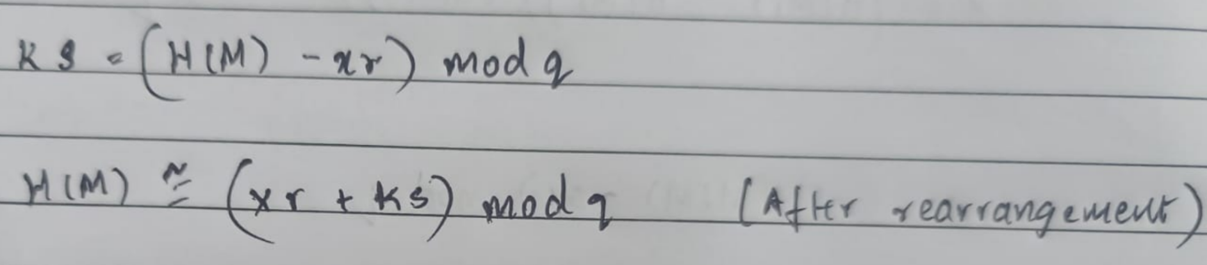
Verification equation:
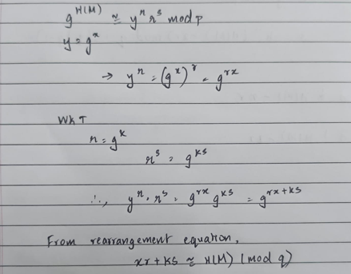
Proof 3: Reused Nonce Attack:
This happens when the signer uses the same nonce k for two different messages M1 and M2. By using the same k, the signer provides linear equations with two variables. This can be solved using elimination method.
MATHS BEHIND THE ATTACK:
  - An attacker can observe the medium and track multiple signatures (r,s1) and (r,s2) where r value is the same. If the r is same k is same and hence the attacker can get the private key using the following mathematical equations
  - SUBTRACT THE TWO SIGNATURE EQUATIONS:
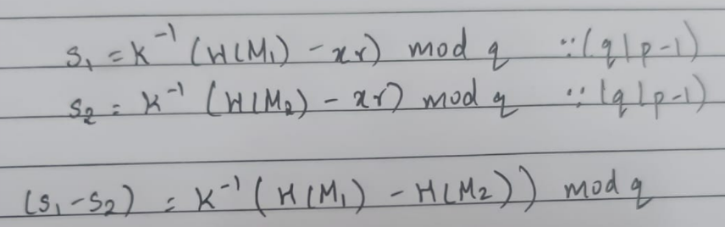
  - SOLVE THE SECRET NONCE K:
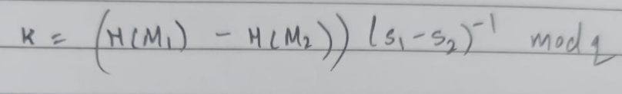
  - SOLVE PRIVATE KEY x:
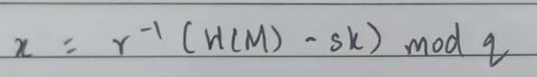
System & Attack Model
System Model
The system model defines the operational environment and the entities involved in the Elgamal Digital Signature process.
KEY GENERATION:
A large prime number p and generator g of order q are selected. (q divides (p-1)).
SENDER:
The signer (Alice) generates private key x (1<=x<=q-1) and uses a unique random nonce k. This unique k must have gcd(k,q) = 1 for the equation to be invertible. This is used in the computation of the signatures (r,s).
RECEIVER:
The verifier (Bob) uses the public key (y = g^{x}modp) and checks whether the signature is valid or not.
INSECURE CHANNEL:
Interception attacks are made possible as attackers can observe multiple signatures and can use reused nonce attack if ephemeral key k is not unique.
Attack Model
This model describes two kinds of security risks:
- The use of a non-coprime random nonce k:
  - The signature equation s = k⁻¹(H(M) – x*r) (mod(q)) where q | (p-1) requires modular inverse of k and gcd(k,q) must be equal to 1. A faulty system provides a $k$ where gcd(k, q) != 1
- Reuse of the nonce which is coprime with q:
  - An attacker can observe the medium and track multiple signatures (r,s1) and (r,s2) where r value is the same. If the r is same k is same and hence the attacker can get the private key using the following mathematical equations
  - SUBTRACT THE TWO SIGNATURE EQUATIONS:

  - SOLVE THE SECRET NONCE K:

  - SOLVE PRIVATE KEY x:

DIAGRAM OF SYSTEM AND ATTACK MODEL:
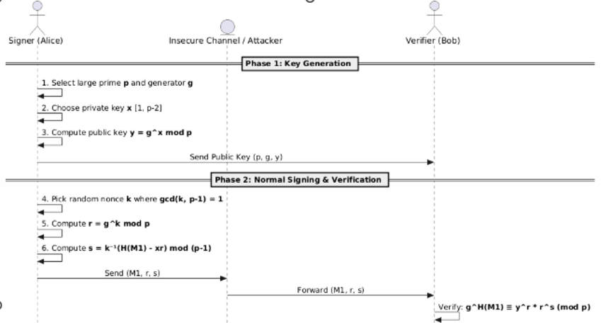
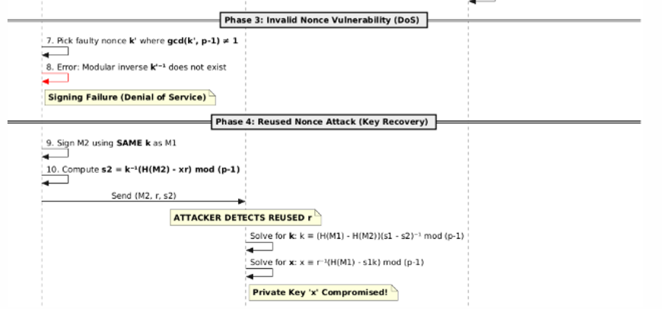
IMPLEMENTATION:
This section presents the implementation of the Elgamal signature system where vulnerability, attack and prevention are discussed.
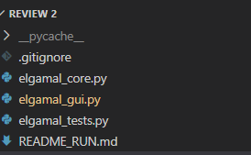
The codebase is divided into three modules:
- elgamal_core.py: This is for mathematical operations required for the signature, attack and nonce generation.
- elgamal_tests.py: Runs scenarios before fix and after fix
- elgamal_gui.py: This is the frontend of the project. This is done using Tkinter and provides 4 buttons. (Generate Keys, Run attack (bad k), Apply prevention, Show graphs)
GUI:
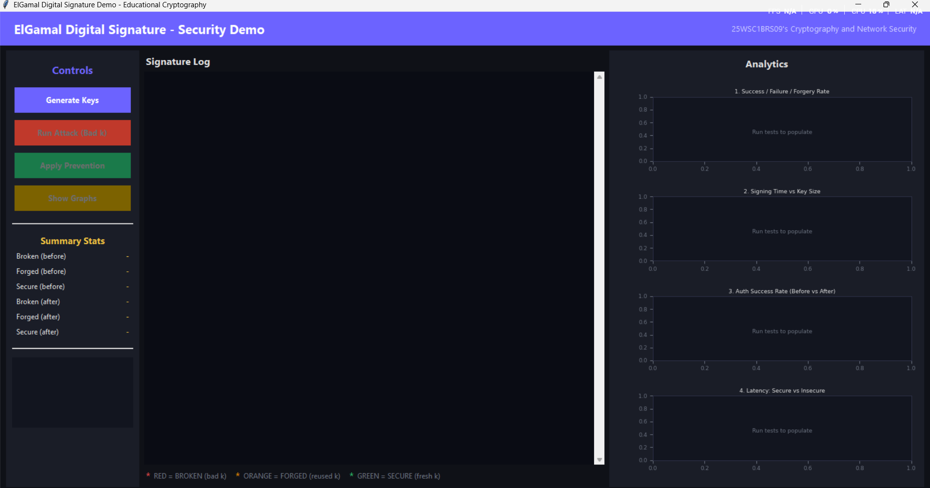
KEY GENERATION: Generates p, generator g, private key x and public key y
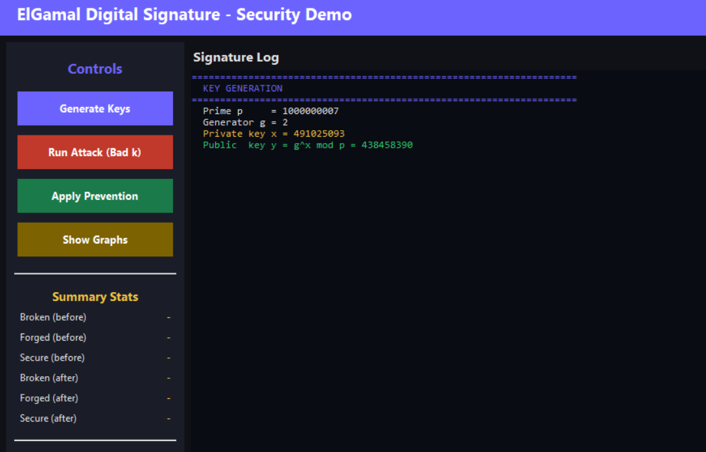

VULNERABILITY IMPLEMENTATION:
Vulnerability is included in the implementation of the code to show that mistake in random nonce generation can make the entire system compromised. It is to note that private key secrecy is alone not enough. We need to ensure that nonce generation is done perfectly unique and gcd(k,q) = 1.
We have incorporated vulnerability by using invalid random nonce and reused random nonce.
Invalid random nonce is invalid k where gcd(k,q) != 1 and the equation is not invertible. Hence s cannot be produced. (Shown in red)
Run Attack: Runs a shuffled scenario of broken and forged:
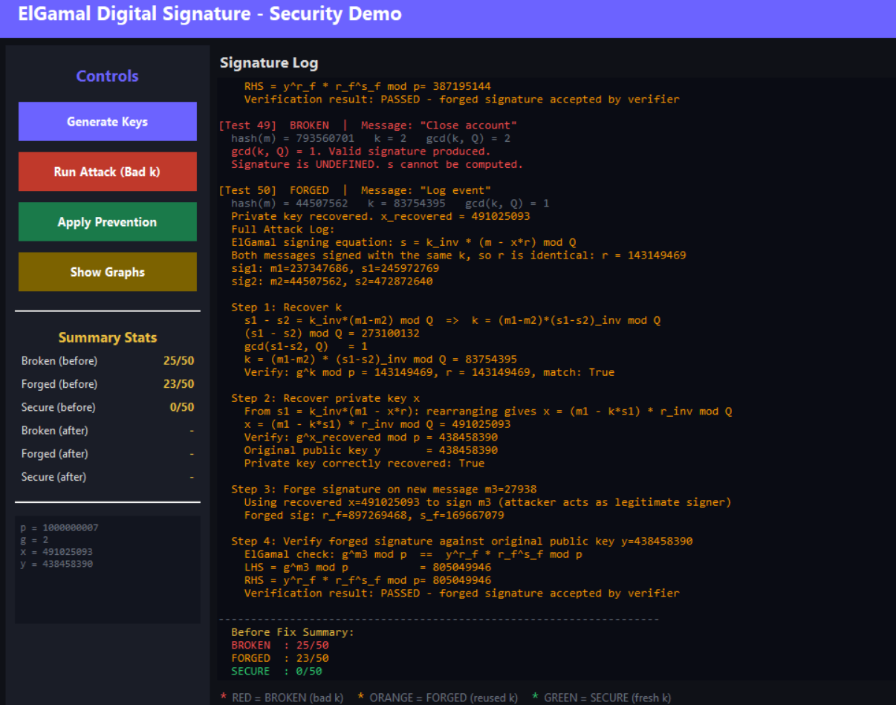
REUSED NONCE ATTACK:
The system accepts two signatures generated under reused nonce condition. When a nonce (k) is reused, same r will be generated i.e (r,s1) and (r,s2). Then it computes modular difference values and using methods of algebra (elimination method) attacker can get private key and forge signatures. Output logs has been shown in the GUI.
We can see that forged signature is verified by the verifier.
PREVENTION:
The implementation includes randomly selecting unique nonce by maintaining a hashset called used_set. This ensures that nonce uniqueness is kept. GCD of k and order q are ensured to be 1 to make the equations invertible.
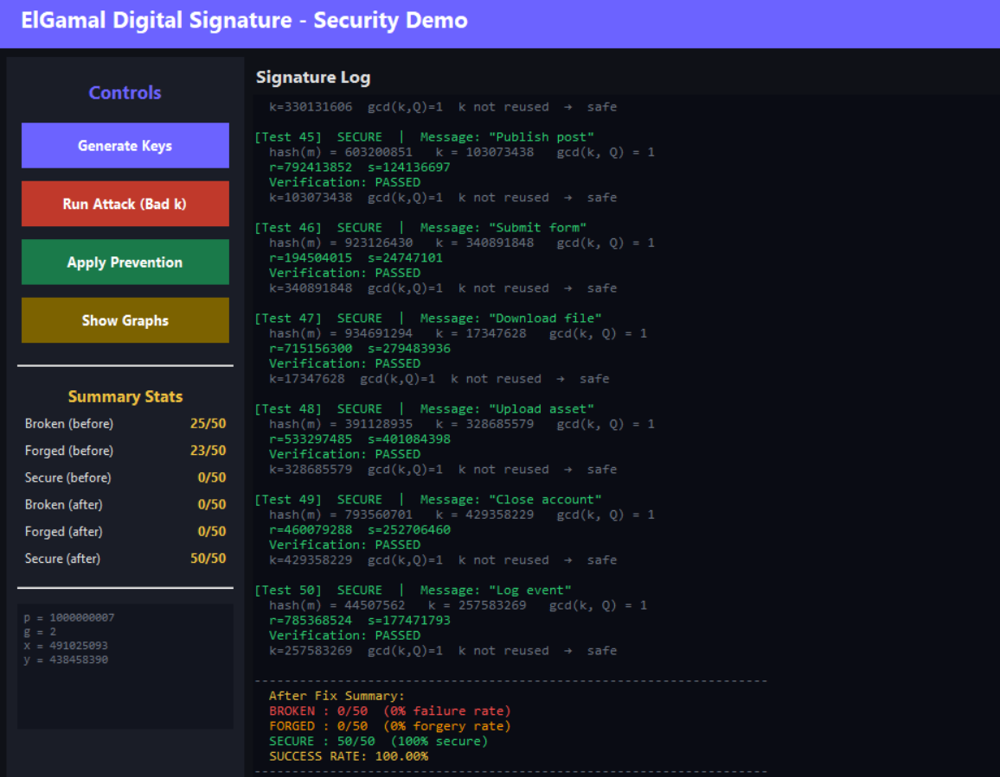

PSEUDOALGORITHM FOR ATTACK:
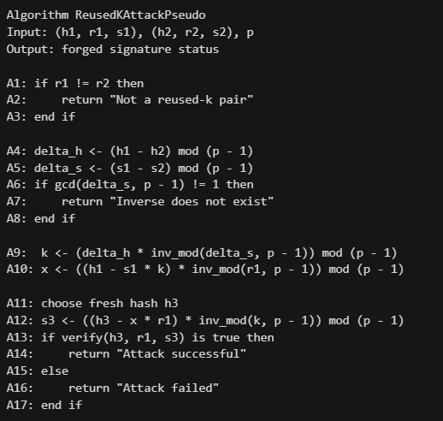
PSEUDOALGORITHM FOR PREVENTION:
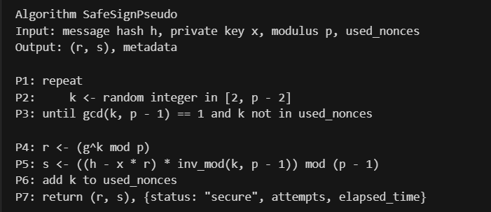
CODE FLOW:
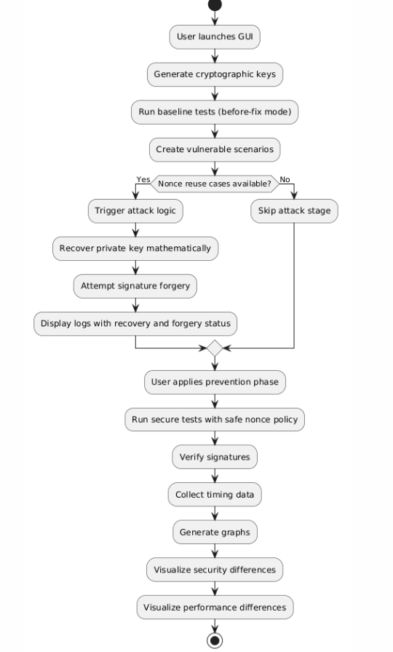
CODE:
GITHUB: https://github.com/githubhealer/Elgamal_signature.git
RESULT:
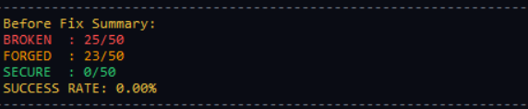
Before checking k: Broken are the cases where gcd(k,q) != 1. Forged are the cases where random nonce is reused.
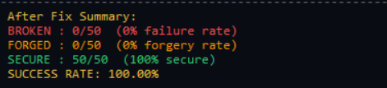
After checking k : Broken are the cases where gcd(k,q) == 1 and every time unique random nonce is generated
GRAPH:
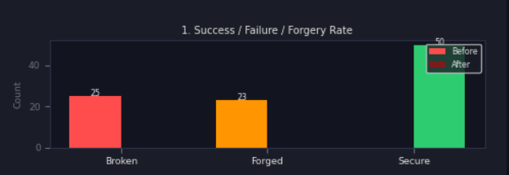
The system runs 50 testcases of insecure and 50 testcases of secure signatures. The bar graph has identified 25/25 broken testcases and 23/25 forged testcases before Fix.
After fix: all 50/50 testcases were secure i.e. use of unique k and checking gcd(k,q) = 1

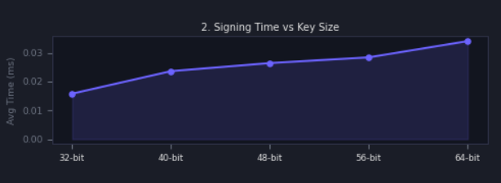
Average sign time increases from 0.015 ms in 32 bit key size to 0.03 ms in 64 bit key size. This tells that as we increase key size, signing time also increases.
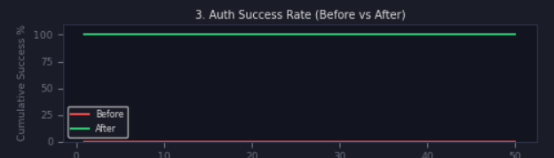
The system runs 50 testcases of insecure and 50 testcases of secure signatures. Before fix the authentication success rate is 0% and after fix it became 100%.
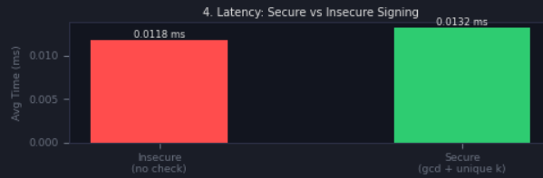
The system shows secure signing takes a slightly higher time than insecure cases. It adds a marginal latency of 0.0014 ms (0.0132 ms vs 0.0118 ms).
Limitations:
- Latency: As shown in the signing time vs key size graph, increasing bit length exponentially increases computational overhead.
- Uniqueness of random nonce: Unique k generation depends on the quality of Random Seed Generator. Therefore we must pick the random seed generator carefully.
- Resource Constraints: In low power consumption IOT devices additional GCD check and validation logics causes device to not properly respond or crash.
Other Approaches:
Deterministic DSA:
Generates random nonce based on the HMAC of the message and private key.This reduces the risk of failure of RNG but increases the CPU usage for hashing.
Elliptic Curve Cryptography:
This uses algebraic curves over finite fields. This provides relatively smaller key sizes for equivalent security but has complex implementation.
Quantum Resistant algorithm:
This uses hash based signatures and provides a barrier against quantum attacks but we need to provide large signature sizes
Conclusion
This study has put forward the transition from before which was an insecure state to after which as a secure state. Implementing GCD validation and ensuring a high entropy k shows how forgery and non-invertibility has been eliminated successfully making the authentication attempts secure and reliable. The implementation shows that the system achieved a authentication success rate = 100% with a negligible latency increase of only 0.0014 ms.
REFERENCES:
Menezes, A. J., van Oorschot, P. C., and Vanstone, S. A. Handbook of Applied Cryptography. CRC Press, 1996.
Boneh, D., and Shoup, V. A Graduate Course in Applied Cryptography. Draft book, 2020.
Smart, N. Cryptography: An Introduction. McGraw-Hill, 2003.
Galbraith, S. Mathematics of Public Key Cryptography. Cambridge University Press, 2012.
Katz, J., and Lindell, Y. Introduction to Modern Cryptography. CRC Press, 2nd Edition, 2014.
Stinson, D. R., and Paterson, M. Cryptography: Theory and Practice. CRC Press, 4th Edition, 2018.
Koblitz, N. A Course in Number Theory and Cryptography. Springer, 2nd Edition, 1994.
Schneier, B. Applied Cryptography: Protocols, Algorithms, and Source Code in C. Wiley, 2nd Edition, 1996.
Stallings, W. Cryptography and Network Security: Principles and Practice. Pearson, 7th Edition, 2017.
Paar, C., and Pelzl, J. Understanding Cryptography: A Textbook for Students and Practitioners. Springer, 2010.

